TECHNICAL PROPOSAL
AWS Hybrid Self-Managed Infrastructure for the EFF Foundation Educational Platform
Designed for scalable K-12 educational services, multi-region resiliency, and future bare-metal migration
Prepared by: Riseup Labs


Table of Contents
1. Executive Summary 3
Proposal Objectives 3
2. Understanding of the Requirement 3
2.1 Project Context 3
2.2 Phase 1 Scope Included 3
2.3 Phase 1 Scope Excluded 4
3. Proposed Technical Approach 4
3.1 Architecture Principles 4
3.2 Edge, Ingress, and Traffic Management 4
3.3 Network Segmentation 4
3.4 Kubernetes Platform Architecture 4
3.5 Data, Storage, and Reporting Architecture 5
3.6 Backup and Disaster Recovery Approach 5
3.7 Security Approach 5
4. Proposed Technical Stack 5
5. Development and Implementation Methodology 7
6. Technical Diagrams 8
7. Deliverables 10
8. Testing and Quality Assurance 10
8.1 QA Coverage Areas 10
8.2 Penetration Testing Scope 10
9. Assumptions, Dependencies, and Out of Scope 11
9.1 Assumptions 11
9.2 Key Dependencies 11
9.3 Out of Scope 11
10. Risks and Mitigation 11
11. Acceptance Criteria 12
12. Conclusion 12

1. Executive Summary
We propose a Phase 1 AWS Hybrid Cloud Infrastructure for the EFF Foundation Educational Platform. The platform will be designed as a self-managed, vendor-neutral infrastructure foundation using AWS primarily for compute, network, and infrastructure hosting, while core platform services remain portable for a future transition to bare-metal or owned data center infrastructure.
The proposed architecture prioritizes scalability, high availability, security, disaster recovery, observability, automation, and cost-aware future portability. It aligns with the approved direction from the architecture review: AWS Hybrid Architecture, self-managed Kubernetes, PostgreSQL, future-ready object storage abstraction, Transit Gateway-based inter-region connectivity, and clear separation between Phase 1 infrastructure and AI/application implementation.

Proposal Objectives
- Establish a secure and scalable AWS hybrid infrastructure foundation for the educational platform.
- Keep the architecture portable by avoiding unnecessary dependency on managed application services.
- Support future growth through horizontal scaling, modular services, and dedicated data/reporting architecture.
- Prepare the platform for future bare-metal migration by using self-managed and open-standard components where applicable.
- Implement observability, CI/CD, backup, disaster recovery, and security controls from the initial phase.

2. Understanding of the Requirement

2.1 Project Context
EFF Foundation is planning a K-12 STEM-focused educational platform with long-term goals around guided learning, adaptive education, reporting, and stakeholder access. This is the proposal for setting up the cloud-hybrid infrastructure and does not include application and AI layer development.
The meeting decisions indicate that AWS Hybrid Architecture is the approved direction, with future migration to bare-metal remaining a strategic objective. The infrastructure proposal also documents assumptions, dependencies, and future migration considerations to prevent misunderstanding during later phases.

2.2 Phase 1 Scope Included
Area | Included Scope
Cloud Infrastructure Foundation | AWS VPC, EC2-based self-managed services, inter-region network design, private routing, Transit Gateway connectivity, and infrastructure bootstrapping.
Edge and Security Layer | Cloudflare for DNS, WAF, DDoS protection, CDN, and rate limiting; PFsense for ingress/egress control, VPN, and segmentation.
Self-Managed Kubernetes Platform | Highly available Kubernetes control plane, dedicated ETCD, worker nodes, autoscaling readiness, Gateway API, ingress/API routing, and Cilium network policies.
Data and Storage Layer | PostgreSQL with Patroni and PgBouncer, Redis, Kafka( requirement is based on scope finalization (final scope may not need it), ClickHouse for analytics/reporting, and MinIO-compatible object storage abstraction.
CI/CD and GitOps | Jenkins, Harbor, ArgoCD, infrastructure-as-code, image scanning, controlled deployment process, and environment promotion.
Observability and Operations | Prometheus, Grafana, ELK/OpenSearch, Sentry, backup monitoring, alerting, and operational dashboards.
Backup and Disaster Recovery | WAL-G, Velero, MinIO replication, configuration backup, recovery validation, and DR simulation readiness.
Security Validation | Security hardening, vulnerability scanning, QA validation, load/stress testing, and penetration testing.

2.3 Phase 1 Cloud-hybrid scope excluded
- AI implementation, RAG model setup, curriculum AI tuning, or AI output validation beyond future architecture planning.
- Application feature development such as learner portal, teacher dashboard, admin workflows, course management, or accreditation workflows.
- Curriculum creation, educational content production, content moderation policy design, or subject-matter expert work.
- Financial costing, infrastructure subscription cost breakdown, or commercial terms.
- Actual bare-metal data center deployment in Phase 1. Phase 1 Cloud-hybrid scope excluded will only prepare the infrastructure architecture for future migration.

3. Proposed Technical Approach

3.1 Architecture Principles
Principle | Application in This Proposal
Vendor-Neutral Platform Services | Use AWS as infrastructure only and keep core services self-managed, portable, and deployable in future bare-metal environments.
Security by Design | Apply zero-trust principles, network segmentation, secrets management, RBAC, image scanning, and controlled ingress/egress.
High Availability and DR Readiness | Design Region A for primary production and Region B for disaster recovery with private replication and failover workflow.
Scalable Data Architecture | Separate transactional database, cache, event streaming, analytics, and object storage so each layer can scale independently.
Automation and Repeatability | Use infrastructure-as-code, CI/CD, GitOps, and automated monitoring to reduce manual operational risk.
Operational Visibility | Implement metrics, logs, traces/errors, alerts, and backup monitoring from the beginning.

3.2 Edge, Ingress, and Traffic Management
The edge layer will protect and optimize access to the platform before requests reach AWS-hosted infrastructure. Cloudflare will be used for DNS, CDN, DDoS protection, WAF policies, rate limiting, and global traffic controls. PFsense will handle firewall rules, VPN connectivity, ingress/egress control, outbound traffic management, and network segmentation. HAProxy will provide routing flexibility, while Kubernetes Gateway API will handle modern ingress/API routing inside the Kubernetes platform.

3.3 Network Segmentation
Network Zone | Purpose
Public Network | Edge ingress, DNS/CDN/WAF termination, and controlled public-facing entry points.
Private Application Network | HAProxy, Kubernetes Gateway API, Kubernetes worker nodes, API gateway, and internal application services.
Private Data Network | PostgreSQL, ClickHouse, MinIO, Redis, Kafka (usage is dependent on scope finalization.), and backup services.
Operations Network | Jenkins, ArgoCD, monitoring stack, administrative access, and secure VPN-based operations.
Inter-Region Network | Replication, backup synchronization, DR traffic, and private Transit Gateway connectivity.

3.4 Kubernetes Platform Architecture
The Kubernetes platform will be self-managed rather than dependent on managed EKS, preserving future portability. Each region will contain a dedicated ETCD cluster, highly available control plane, and worker nodes designed for horizontal growth. Application workloads will use Kubernetes autoscaling policies, resource limits, health checks, and network policies. Cilium will provide Kubernetes networking, eBPF acceleration, and service-level security controls.

3.5 Data, Storage, and Reporting Architecture
PostgreSQL will be the primary transactional database, supported by Patroni for failover and PgBouncer for connection pooling. Redis will support sessions, cache, token management, and rate limiting. Kafka will handle event streaming for activity tracking, notifications, audit events, analytics, and future AI workflows (Depends on scope.). ClickHouse is recommended from the beginning for learning analytics, reporting dashboards, accreditation reporting, and large-volume analytical queries. MinIO-compatible object storage will store media, documents, videos, course materials, and future AI content while maintaining portability.

3.6 Backup and Disaster Recovery Approach
The DR approach will follow an active-passive model. Region A will operate as primary production, while Region B will act as standby DR environment. PostgreSQL will use WAL archiving and cross-region replication; MinIO will use site replication/versioning; Kubernetes resources will be backed up using Velero; infrastructure configuration will be preserved through Git repositories and backup storage.
Recovery Metric | Target
Recovery Point Objective (RPO) | 15 minutes or better, subject to final replication tuning
Recovery Time Objective (RTO) | Within 1 hour for regional failover target
Database Node Failover | Target under 60 seconds for single node failure
Kubernetes Recovery | Target 1-2 hours depending on cluster rebuild scenario

3.7 Security Approach
Security will be implemented across edge, network, cluster, CI/CD, application runtime, and operations. The design includes WAF/DDoS protection, network segmentation, PFsense controls, RBAC, Kubernetes network policies, Pod Security Standards, image signing/scanning, HashiCorp Vault for secrets, internal mTLS where applicable, and DevSecOps checks through CI/CD pipelines.

4. Proposed Technical Stack
Layer | Recommended Tools / Technologies | Purpose
Cloud Infrastructure | AWS EC2, VPC, Transit Gateway, Route Management | Infrastructure hosting and private connectivity while keeping services self-managed.
Edge Security and CDN | Cloudflare | DNS, CDN, DDoS protection, WAF, and rate limiting.
Firewall / VPN | PFsense | Ingress/egress control, VPN access, network segmentation, and outbound policy management.
Load Balancing / Ingress | HAProxy, Kubernetes Gateway API | Flexible Layer 4/Layer 7 routing and API gateway traffic management.
Container Platform | Self-managed Kubernetes, ETCD, Cilium | Portable orchestration layer with secure networking and horizontal scaling.
Database | PostgreSQL, Patroni, PgBouncer, WAL-G | Transactional storage, HA failover, connection pooling, and PITR backup support.
Analytics Database | ClickHouse | High-volume reporting, learning analytics, and stakeholder dashboards.
Cache / Session Layer | Redis Cluster | Sessions, token management, cache, leaderboards, and rate limiting.
Event Streaming | Apache Kafka | Scope dependent
Object Storage | MinIO-compatible storage | Media, course materials, documents, videos, and portable object storage abstraction.
CI/CD | Jenkins, Harbor, ArgoCD | Build, test, scan, image registry, and GitOps deployment automation.
Secrets Management | HashiCorp Vault | Secrets, database credentials, API keys, certificates, and secure secret rotation readiness.
Observability | Prometheus, Grafana, ELK/OpenSearch, Sentry | Metrics, dashboards, centralized logs, application errors, and alerts.
Backup and DR | Velero, WAL-G, MinIO Replication, Git-based configuration backup | Database, Kubernetes, object storage, and configuration recovery.
Security Testing Tools | SonarQube, Trivy, OWASP-aligned testing tools | Code quality, dependency/image scanning, and penetration testing support.
Preliminary Monthly Infrastructure Cost Assumption
Important pricing note: The following table is a preliminary monthly infrastructure estimate for the current proposal components. It is infrastructure-only and excludes implementation labor, application development, taxes, premium support, third-party license fees, and AI model token/inference consumption. Final pricing should be recalculated after target AWS region, traffic, storage, concurrency, and retention assumptions are confirmed.
Indicative monthly estimate: Approximately US$7.8k-8.3k / month
Component group | Assumption used | Estimated monthly cost
Cloudflare Business + edge security | 1 zone / app used as placeholder for DNS, CDN, WAF, DDoS protection, and rate limiting. Akamai alternative to be estimated separately if selected. | US$200
AWS network foundation | Two-region VPC baseline, Transit Gateway attachments, route management, VPN/NAT planning allowance, and private connectivity reserve. | ~US$350
Firewall / VPN layer | 2 x PFsense EC2 nodes for ingress/egress control, VPN access, segmentation, EBS, and small network reserve. | ~US$100
Load balancing / ingress | AWS ALB/NLB usage allowance plus HAProxy ingress nodes for controlled Layer 4/Layer 7 routing. | ~US$180
Kubernetes control plane + ETCD | 6 x control plane / ETCD EC2 nodes across primary and standby DR footprint, including baseline EBS storage. | ~US$480
Kubernetes worker pool | 6 x general-purpose EC2 worker nodes for application/platform workloads, autoscaling readiness, and baseline EBS storage. | ~US$960
PostgreSQL HA + PgBouncer + WAL-G | 3 x database-class EC2 nodes with Patroni, PgBouncer, WAL-G, gp3 storage, and backup archive allowance. | ~US$850
Redis cache | 3 x EC2 cache/session nodes with storage and availability reserve. | ~US$270
Kafka event streaming (scope dependent) | 3 x EC2 broker nodes with durable storage allowance for activity, audit, notification, analytics, and future AI event flows (scope dependent). | ~US$670
ClickHouse analytics database | 3 x analytics EC2 nodes with gp3 storage allowance for reporting, learning analytics, and stakeholder dashboards. | ~US$850
MinIO-compatible object storage | 3 x storage nodes plus EBS/S3-compatible storage allowance for media, documents, course materials, and backup objects. | ~US$1,020
CI/CD and GitOps | Jenkins, Harbor, and ArgoCD on 2-3 small/medium EC2 nodes with registry storage allowance. | ~US$300
Secrets management | HashiCorp Vault HA baseline on 3 small nodes for secrets, credentials, certificates, and rotation readiness. | ~US$120
Observability stack | Prometheus, Grafana, ELK/OpenSearch, and Sentry nodes with log retention/storage/headroom allowance. | ~US$770
Backup and DR reserve | Velero, WAL-G archive storage, snapshots, cross-region replication traffic, restore validation, and DR testing allowance. | ~US$600
Security scanning tools | SonarQube/Trivy runner capacity and scanning job headroom. Commercial security-tool licensing is excluded. | ~US$150
Total planning estimate | Baseline production HA + standby DR footprint. Final cost may increase or decrease based on sizing, region, traffic, retention, and storage volume. | ~US$7,870

5. Development and Implementation Methodology
The implementation will follow an Agile infrastructure delivery model combined with Infrastructure-as-Code and GitOps. This allows the team to deliver the platform in controlled increments, validate every layer, and keep deployment configurations repeatable for future environments.
Step | Description
1. Architecture Validation | Confirm target AWS regions, network CIDR, security boundaries, access model, DR expectations, and final component choices.
2. Infrastructure as Code | Prepare reusable Terraform modules/scripts for AWS infrastructure bootstrap, network foundation, compute nodes, and baseline security.
3. Platform Build | Deploy self-managed Kubernetes, ETCD, ingress, Cilium, core namespaces, baseline policies, and cluster operations tooling.
4. Data Services Setup | Deploy PostgreSQL HA, Redis, Kafka (scope dependent), ClickHouse, MinIO abstraction, backup tooling, and replication mechanisms.
5. CI/CD and GitOps | Configure Jenkins, Harbor, ArgoCD, branch/deployment flow, security scanning, image publishing, and deployment synchronization.
6. Observability and DR | Configure monitoring, dashboards, logging, alerts, backup validation, DR runbook, and failover workflow.
7. QA, Security, and Performance Validation | Execute environment validation, load/stress testing, vulnerability assessment, penetration testing, and operational acceptance checks.
8. Handover and Documentation | Prepare architecture documents, deployment guides, backup/restore guide, monitoring guide, security checklist, and admin handover.

6. Technical Diagrams
The following diagrams are included to support proposal quality and provide space for final visual refinement during design formatting. The titles and technical flow should remain consistent even if the client-facing artwork is later redesigned.
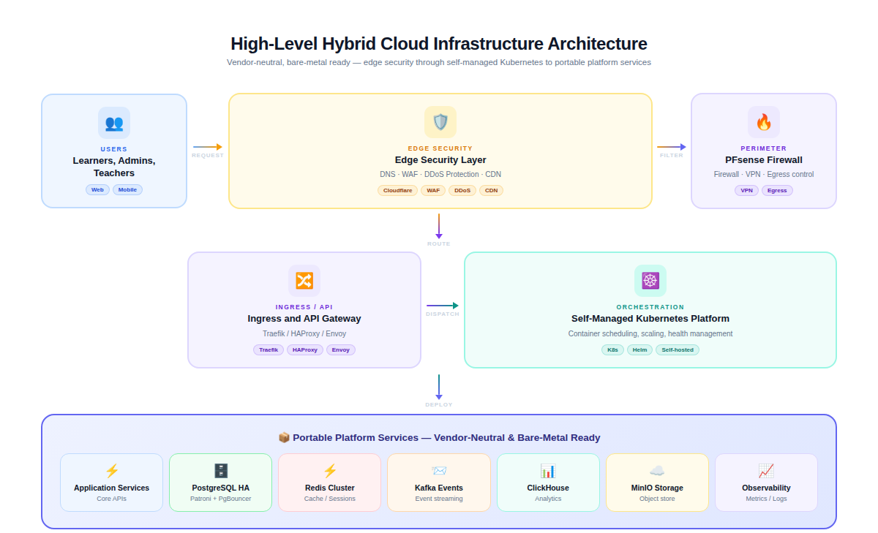
Figure 1: High-Level Hybrid Cloud Infrastructure Architecture
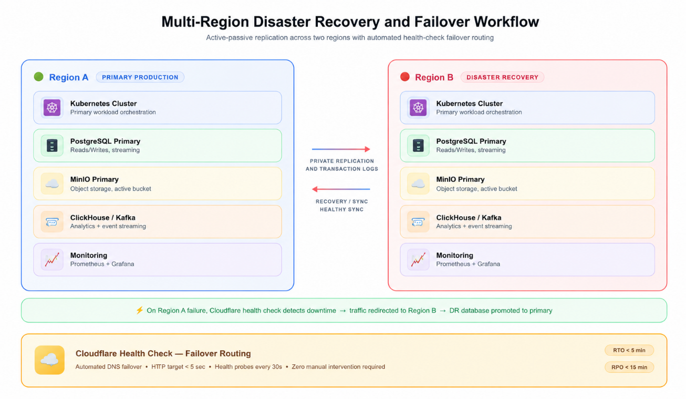ssssssssssssss
Figure 2: Multi-Region Disaster Recovery and Failover Workflow
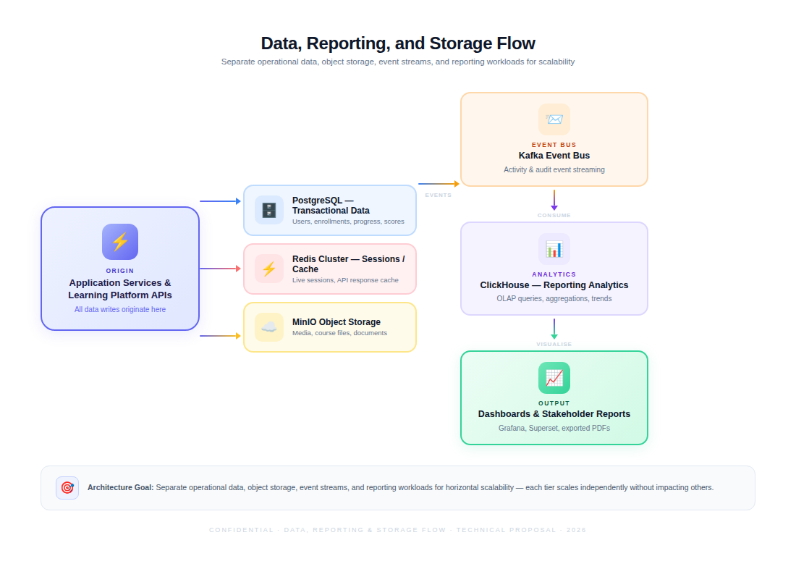
Figure 3: Data, Reporting, and Storage Flow
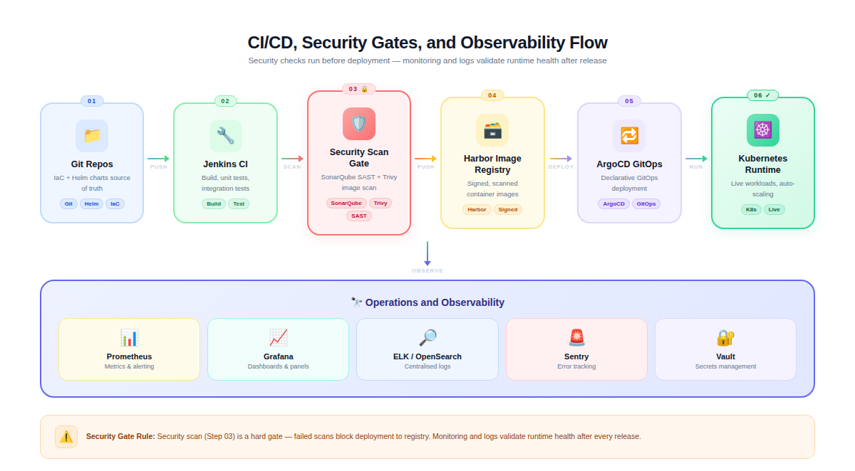
Figure 4: CI/CD, Security Gates, and Observability Flow

7. Deliverables
Deliverable Category | Deliverable Description
Architecture and Planning | Final infrastructure architecture, network segmentation plan, deployment approach, DR design, security baseline, and future bare-metal migration dependency note.
AWS Infrastructure Foundation | Configured AWS VPC/networking, EC2-based compute foundation, Transit Gateway setup, route/security controls, and region-specific environment structure.
Kubernetes Platform | Self-managed Kubernetes cluster, ETCD, worker nodes, Gateway API/ingress setup, Cilium networking, namespaces, RBAC, and baseline policies.
Data Platform | PostgreSQL HA design with Patroni/PgBouncer, Redis, Kafka (scope dependent), ClickHouse, MinIO-compatible object storage setup, and initial backup/replication configuration.
CI/CD and GitOps | Jenkins CI pipeline, Harbor registry, security scanning workflow, ArgoCD deployment sync, and Git-based configuration management.
Observability | Prometheus metrics, Grafana dashboards, ELK/OpenSearch logging, Sentry error tracking, alerting rules, and operational dashboards.
Backup and DR | WAL-G database backup, Velero Kubernetes backup, MinIO replication, restore validation, DR workflow, and recovery runbook.
Security and QA Reports | QA test summary, load/stress testing summary, vulnerability scan report, penetration testing executive summary, and remediation tracker.
Handover Documents | Deployment guide, operations guide, monitoring guide, backup/restore guide, access management guide, and final technical handover session.

8. Testing and Quality Assurance
Testing will focus on validating the infrastructure foundation, security posture, scaling readiness, monitoring, backup/DR readiness, and operational stability.

8.1 QA Coverage Areas
QA Area | Validation Focus
Infrastructure Validation | Verify VPC, routing, firewall, DNS, load balancing, ingress, private connectivity, and segmentation rules.
Kubernetes Validation | Validate control plane health, worker scheduling, ETCD health, HPA readiness, network policies, service routing, and namespace isolation.
Data Service Validation | Validate PostgreSQL replication/failover, PgBouncer connection pooling, Redis cluster health, Kafka topics/consumers (scope dependent), ClickHouse ingestion, and MinIO availability.
Backup and Restore Testing | Run backup integrity checks, database restore test, Kubernetes resource restore test, and object storage restore test.
Disaster Recovery Simulation | Validate Region A failure workflow, traffic redirection concept, PostgreSQL promotion runbook, and Region B service activation process.
Performance and Load Testing | Simulate high concurrent access patterns, evaluate ingress capacity, API gateway behavior, database connection limits, and autoscaling readiness.
Security Testing | Run vulnerability scanning, image scanning, dependency scanning, configuration review, network exposure checks, and secrets handling validation.
Documentation QA | Validate deployment instructions, recovery runbooks, monitoring guides, access management steps, and handover materials.

8.2 Penetration Testing Scope
A penetration testing activity will be included after the environment is stable enough for security validation. The test will be conducted at a controlled level against the approved infrastructure scope and will follow an OWASP-aligned methodology for web/API exposure and infrastructure access review.
Penetration Testing Stage | Activities
Pre-Test Planning | Confirm scope, permitted test windows, target domains/IPs, access level, environment readiness, and reporting format.
External Exposure Review | Assess public endpoints, DNS/WAF behavior, TLS configuration, open ports, ingress policies, and rate limiting behavior.
Web/API Security Testing | Validate authentication surfaces, authorization boundaries where available, API gateway behavior, common web risks, headers, and request handling.
Infrastructure Security Review | Review firewall rules, VPN access, Kubernetes API exposure, RBAC, network policies, secrets management, and container image posture.
Reporting and Remediation | Provide executive summary, risk rating, affected components, evidence summary, remediation recommendations, and retest plan.

9. Assumptions, Dependencies, and Out of Scope

9.1 Assumptions
- The client will provide or approve AWS account access, target regions, domain/DNS details, and necessary infrastructure ownership policies.
- The Phase 1 cloud-hybrid scope is limited to cloud infrastructure foundation and platform services required to support future bare-metal switch.
- Application traffic patterns, exact learner volume, reporting volume, and AI workloads will be refined in later planning phases.
- Security testing will be performed only against approved systems and within agreed windows.

9.2 Key Dependencies
- AWS account readiness, billing ownership, IAM access, and region approvals.
- Domain/DNS ownership and decision on Cloudflare edge provider.
- VPN and administrative access policy approval.
- Final confirmation of DR region, backup retention expectations, and compliance requirements.
- Future application and AI architecture details for final sizing and scaling adjustments.

9.3 Out of Scope
- End-user application development or UI/UX implementation.
- Financial cost estimates, licensing cost comparison, or commercial proposal.
- Bare-metal hardware procurement, data center deployment, or physical network implementation in Phase 1.

10. Risks and Mitigation
Risk | Impact | Mitigation
Hybrid Complexity | Self-managed Kubernetes and portable services require more engineering than fully managed services. | Use IaC, GitOps, documented runbooks, phased validation, and operations handover.
Future Reporting Load | Administrators, teachers, agencies, and stakeholders may need heavy reporting capabilities. | Use ClickHouse and separate reporting/data pipelines to reduce pressure on PostgreSQL.
Bare-Metal Migration Expectations | Future migration may be misunderstood as automatic without prerequisite planning. | Document migration dependencies, component portability, storage strategy, and network prerequisites.
Operational Overhead | Self-managed infrastructure requires ongoing monitoring, patching, and incident response. | Implement observability, alerts, backup validation, and clear operations responsibilities.
Security Exposure | Public educational platforms face DDoS, credential, API, and misconfiguration risks. | Use WAF/DDoS protection, network segmentation, RBAC, scanning, hardening, and penetration testing.
DR Validation Gap | DR design may not work as expected unless tested regularly. | Include restore testing, DR simulation, replication monitoring, and documented recovery runbooks.

11. Acceptance Criteria
- AWS infrastructure foundation is provisioned according to the approved network and security design.
- Self-managed Kubernetes cluster is operational with validated ingress, network policy, RBAC, and baseline observability.
- PostgreSQL, Redis, Kafka (scope dependent), ClickHouse, and MinIO-compatible storage are installed/configured according to the approved architecture.
- CI/CD and GitOps workflow can build, scan, publish, and deploy a sample workload successfully.
- Monitoring dashboards, alerting, centralized logging, and error tracking are configured for core platform services.
- Backup and restore procedures are documented and validated through representative test cases.
- Load/stress testing and security validation are completed, with findings documented and remediation actions tracked.
- Penetration testing executive summary and remediation tracker are delivered for the approved testing scope.
- Final architecture, operations, backup/restore, monitoring, and handover documentation are delivered.

12. Conclusion
The proposed Phase 1 architecture provides a secure, scalable, and portable infrastructure foundation for the EFF Foundation Educational Platform. It supports the approved AWS Hybrid Architecture direction while reducing long-term dependency on managed application services and preserving a clear path toward future bare-metal migration.
By implementing self-managed Kubernetes, PostgreSQL HA, ClickHouse analytics, MinIO-compatible storage, CI/CD with GitOps, observability, backup/DR readiness, vulnerability scanning, load testing, and penetration testing, the platform will be positioned for long-term growth and controlled future expansion into application and AI-enabled educational capabilities.

